**TEAM MEMBERS**

**1. B. MUTHULAKSHMI**

**2. K. SUDHARSAN**

**3. P. GOKULRAJ**

**4. M. VIGNESH**

# REGISTER

<html>

<center>

<H2>

<form action="action_page.php">

<div class="container">

<body background="C:\Users\admin\Downloads\PIC.jpg">

<h2>REGISTER</h2>

<p>Please fill in this form to create an account.</p>

<label for="email"><b>Email</b></label>

<input type="text" placeholder="Enter Email" name="email" id="email" required></br></br>

<label for="psw"><b>Password</b></label>

<input type="password" placeholder="Enter Password" name="psw" id="psw" required></br></br>

<label for="psw-repeat"><b>Confirm Password</b></label>

<input type="password" placeholder="Repeat Password" name="psw-repeat" id="psw- repeat" required></br></br>

<button type="submit" class="registerbtn">Register</button></br> </div>

</form>

</H2>

</center>

</html>

**OUTPUT:**

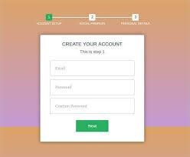

# LOGIN

<html>

<center>

<form action="action_page.php">

<div class="container">

<body background="C:\Users\admin\Downloads\PIC.jpg">

<h1>LOGIN</h1>

<label for="email"><b>Email</b></label>

<input type="text" placeholder="Enter Email" name="email" id="email" required></br></br>

<label for="psw"><b>Password</b></label>

<input type="password" placeholder="Enter Password" name="psw" id="psw" required></br></br>

<button type="submit" class="registerbtn">Login</button></br>

</div>

<div class="container signin">

</div>

</form>

</center>

</html>

**OUTPUT:**

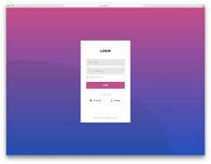

# UPLOAD IMAGE

<html>

<body>

<center>

<body background="C:\Users\admin\Downloads\PIC.jpg">

<form action="upload.php" method="post" enctype="multipart/form-data">

<h2> SELECT IMAGE TO UPLOAD </br></br>

<input type="file" name="fileToUpload" id="fileToUpload"></br></br>

<input type="submit" value="Upload Image" name="submit"></br>

</form>

</center>

</body>

</html>

**OUTPUT:**

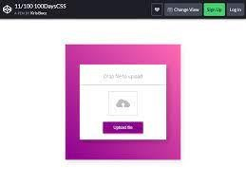

# PREDICTION RESULTS PAGE FOR FOOD ITEMS

<html>

<head> <style> div {

background-color: #FFBEBC; width: 200px; border: 15px solid grey; padding: 70px; margin: 50px;

} table {

font-family: arial, sans-serif; border-collapse: collapse; width: 50%; } td {

border: 1px solid #dddddd; text-align: left; padding: 8px; background-color: #5F9EA0;

}

tr:nth-child(even) {

background-color: #dddddd;

}

</style>

<body>

<center>

<body background="C:\Users\admin\Downloads\PIC.jpg">

<h2> RESULTS </br></br>

<div>Uploaded image</div>

<h3>Nutritional Facts</h3>

<table>

<tr>

<td>Calories</td>

<td>value</td>

</tr>

<tr>

<td>Protein</td>

<td>value</td>

</tr>

<tr>

<td>Carbs</td>

<td>value</td>

</tr>

<tr>

<td>Fat</td>

<td>value</td>

</tr>

</center>

</body>

</html>

**OUTPUT:**



# VIEW HISTORY OF ITEMS

<html>

<head>

<style>

table, th, td {

border:1px solid black;

}

.table1 {

font-family: arial, sans-serif; border-collapse: collapse; width: 50%;

}

.table1 td {

border: 1px solid #dddddd; text-align: left;

padding: 8px;

background-color: #CE9DD9;

}

.table1 tr:nth-child(even) { background-color: #dddddd;

}

</style>

</head>

<body>

<center>

<body background="C:\Users\admin\Downloads\PIC.jpg">

<h2> HISTORY </h2> </br></br>

<h1> Tracker </h1>

<table style="width:50%">

<tr>

<td>Calorie limit</td>

<td>value</td>

</tr>

<tr>

<td>Total Calories consumed</td>

<td>value</td>

</tr>

<tr>

<td>Left</td>

<td>value</td>

</tr>

</br></br>

</table>

<h2>History of food-items</h2>

<table class="table1">

<tr>

<th>Food-items</th>

<th>Calories</th>

<th>Proteins</th>

<th>Carbs</th>

<th>Fat</th>

</tr>

<tr>

<td>food 1</td>

<td>value</td>

<td>value</td>

<td>value</td>

<td>value</td>

</tr>

<tr>

<td>food 2</td>

<td>value</td>

<td>value</td>

<td>value</td>

<td>value</td>

</tr>

<tr>

<td>food 3</td>

<td>value</td>

<td>value</td>

<td>value</td>

<td>value</td>

</tr>

<tr>

<td>food 4</td>

<td>value</td>

<td>value</td>

<td>value</td>

<td>value</td>

</tr>

</center>

</body>

</html>

**OUTPUT:**

